PWA 16- getting cached assets

<https://www.youtube.com/watch?v=0mAw9Na6hyM>

Online

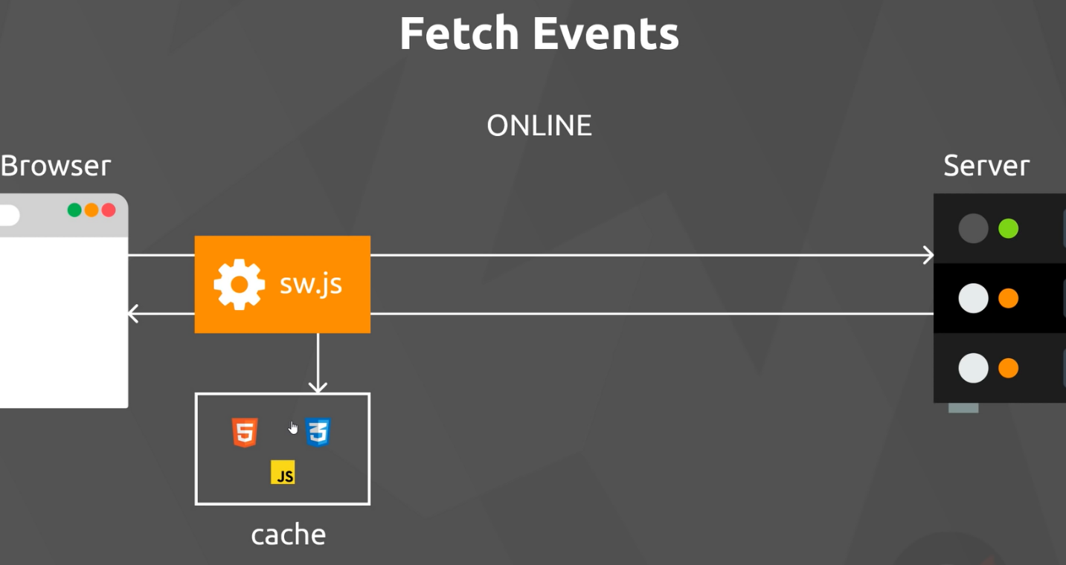

Offline

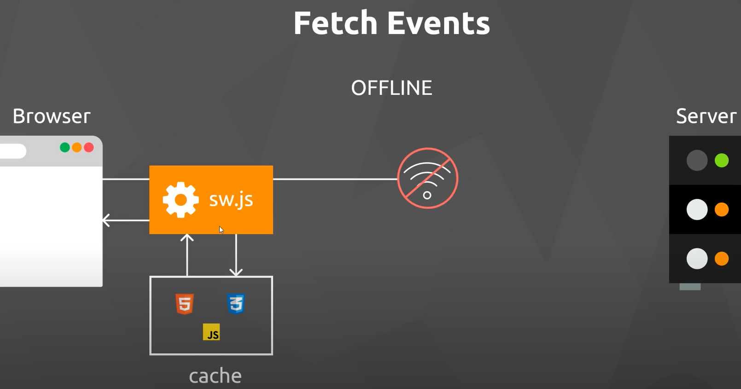

Need to intercept the request for static requests so that they do not need to go to the server. Can do this in the fetch event addEventListenter. It fires with every fetch request done by the browser. The request in the fetch event

